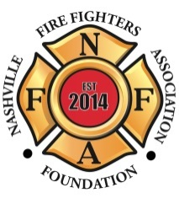 NASHVILLE FIRE FIGHTERS 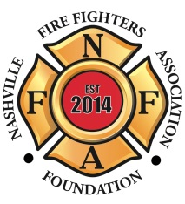
ASSOCIATION FOUNDATION

8th Annual
CHARITY GOLF TOURNAMENT

May 29, 2019

The Nashville Fire Fighters Association Foundation will be hosting our 8th Annual Charity Golf Tournament on May 29, 2019 to benefit the NFFA Foundation Disaster Relief Fund. This year the tournament will be played at the Hermitage Golf Course General’s Retreat, 3939 Old Hickory Blvd, Old Hickory, TN 37138. Our Disaster Relief Fund was established in 2010 during the historic May flood to help our Brothers and Sisters whose lives were affected by the disaster. Since its inception, we have helped well over 100 of our Union Brothers and Sisters whose lives were negatively affected by disaster, injury or illness from all over the United States. The Nashville Fire Fighters Association Foundation, a 501-(c)(3) non-profit charitable foundation with the IRS and the State of Tennessee, was created to help expand our ability to raise funds for the many charities that we support.
Tournament format will be an 18-hole, 4-man scramble. Registration is $100 per golfer. (Range balls are included.) There will be prizes for longest drive and closest to the pin, hole in one prizes, a putting contest, raffle prizes and more. All beverages will be provided and a catered meal will follow the tournament. Early Registration is strongly encouraged to expedite check-in the morning of the tournament. There are only 144 spots available. Get your team of 4 golfers and let's raise money for the Nashville Fire Fighters Association Foundation Disaster Relief Fund. There will be an after party at Sam’s Sports Grill - Blue Turtle Bay, 2001 Lakeshore Drive, Old Hickory, TN.

NASHVILLE FIRE FIGHTERS FOUNDATION
Presents
8th Annual Charity Golf Tournament
May 29, 2019
8:00am Shotgun Start
$100/Player

Hermitage Golf Course, 3939 Old Hickory Blvd,
Old Hickory, TN 37138

This tournament is to benefit the Nashville Fire Fighters Association Foundation Disaster Relief Fund. Appropriate golf attire is required. All participants are required to wear soft spikes, collared shirts and khaki shorts or pants. No cargo pants, t-shirts, tank tops, cut-offs, sweat pants, bathing suits, athletic shorts, or denim are permitted.

Name___________________________

Name___________________________

Name___________________________

Name___________________________

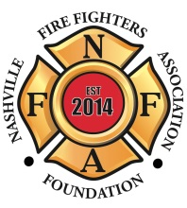

Nashville Fire Fighters
Association Foundation

Below is a list of ways you can contribute to this event. Please take time to look them over and hopefully you can find a way to participate.

Gold Sponsor - $1,000 Donation
Entry for a 4-player team in the tournament
Company name or logo featured electronically on golf cart on sponsored hole
Special recognition at the awards ceremony
Opportunity to distribute product information in golf gift bags
Recognition of sponsorship in NFFA Foundation PR efforts

Hole Sponsor - $250 Donation
Company name or logo featured on tee box on sponsored hole

Firehouse Challenge - $100 Donation
This is a challenge put out to all Nashville Fire Stations. Your Station will get a sponsored hole with a sign on the tee box and special recognition at the awards ceremony. Remember, this is for the NFFA Foundation Disaster Relief Fund that supports our own.

Donation
If you are unable to participate in the golf tournament, but would still like to make a donation to the Foundation, any amount would be greatly appreciated.

Please make checks payable to: NFFA Foundation
A 501-(c)(3) charitable foundation (EIN 46-4764024)

If you have any questions, please contact the Tournament Directors:
Barry Byers (615) 739-4928
Justin Griggs (615) 456-9502
Ben Rager (615) 566-4801
Brian Burnett (615) 573-4575
Jonathan Secrest (615) 496-4933
Blake Emmalie (615) 815-6169

Please mail or drop off completed flier and payment to:

Nashville Fire Fighters Association Foundation

100 Arlington Ave.
Nashville, TN 37210
Phone: 615-401-6133

